43.2: a) Using 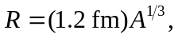 the radii are roughly 3.6 fm, 5.3 fm, and 7.1 fm.
b) Using 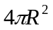for each of the radii in part (a), the areas are 163 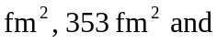
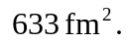
c) 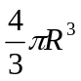gives 195 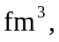 624 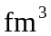 and 1499 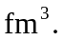
d) The density is the same, since the volume and the mass are both proportional to A:
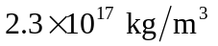 (see Example 43.1).
e) Dividing the result of part (d) by the mass of a nucleon, the number density is 